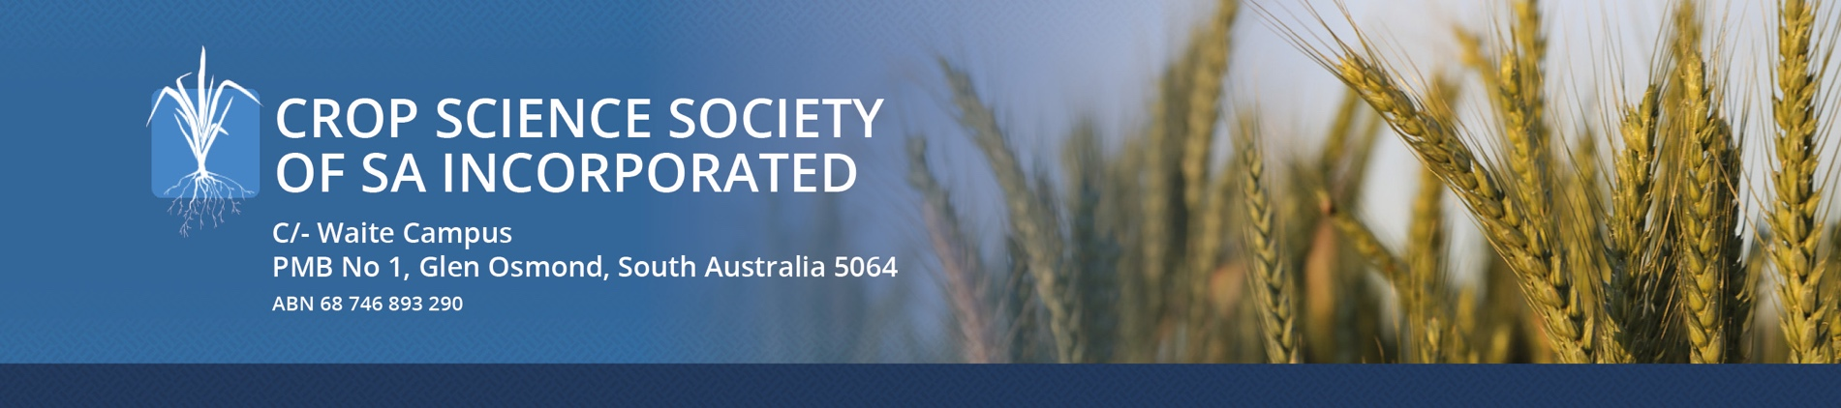

MEMBERSHIP FORM
Join others engaged in the production and/or study of crop plants or weeds by becoming a
Crop Science Society of South Australia member.

NAME _____________________________________________________________________

COMPANY /
TRADING NAME _____________________________________________________________________

ADDRESS _____________________________________________________________________

_____________________________________________________________________

PHONE _____________________________________________________________________
(for SMS alerts)

EMAIL _____________________________________________________________________
(for newsletter)

ACTIVE MEMBER You will receive a monthly newsletter and are welcome to
Dues $30.00 attend meetings, held on the third or fourth Wednesday
of the month at the University of Adelaide’s Roseworthy
Campus.

Please send your completed membership form, along with payment to;

Payment options:
EFT
BSB 015 560 ACCOUNT 4114 69065
Name: Crop Science Society of South Australia
Please use YOUR NAME as your reference and
email this form along with confirmation of payment to cropsssa@gmail.com

CHEQUE – by prior arrangement
Crop Science Society of South Australia Inc
C/- Waite Campus
PMB No 1,
Glen Osmond, South Australia 5064

Crop Science Society of SA Inc │ C/- Waite Campus │ PMB No 1 │ Glen Osmond, South Australia 5064

